Note no: 4
Imposition of (ECC) Environment Compensation Charge: status of enforcement and impact of orders on air quality
EPCA, Environment Pollution (Prevention & Control) Authority for Delhi and NCR
February 18, 2016
Direction from the Hon’ble Supreme Court
Order dated 09.10.2015
“It has been pointed out that even though alternative routes are available for such traffic, only reason for such traffic entering into Delhi is to save higher rate of toll tax in taking such alternative routes. In the process, pollution caused by such traffic inflicts heavy cost on the health of the residents of Delhi. To tackle this situation an ‘Environment Compensation Charge’ (ECC) may be required to be imposed on all light and heavy duty commercial vehicles and the amount so collected ought to be exclusively used for augmenting public transport and improving roads particularly for most vulnerable users, that is, cyclist and pedestrians in Delhi.”
ECC ought to be imposed by the Delhi Government at the following rates:
- Category 2 (light duty vehicles etc.) and Category 3 (2-axle trucks) - Rs. 700/-
- Category 4 (3-axle trucks) and Category 5 (4-axle trucks and above) - Rs. 700/-
The above charge shall not be imposed on
- Passenger vehicles and ambulances
- On vehicles carrying essential commodities, that is, food stuffs and oil tankers”
Order dated 16.12.2016
“We are further of the view that empty/unladen vehicles bound for Delhi, can enter Delhi on payment of the ECC earlier stipulated by us at Rs.700/- and Rs.1300/- per vehicle depending upon the category to which the vehicle belongs. We, however, direct that for Delhi bound vehicles loaded with goods, the ECC will be twice the charges stipulated by us by order dated 09.10.2015. This measure shall, in our opinion, discourage any vehicles trying to enter Delhi on a false pretext of the goods loaded on it being Delhi bound.”
A. Status of compliance
- EPCA report dated October 2015 had estimated that light and heavy-duty commercial trucks contributed some 30 per cent of the PM load of transport sector.
- EPCA, based on a study commissioned through V R Techniche Consultants had estimated that on a daily basis there were 38,588 commercial vehicles in category 2-5 that entered Delhi from 9 main entry points.
- The toll concessionaire SMYR Consortium LLP has given an estimate that there has been a 30 per cent decline in commercial vehicle entry post since November 6 2015 – when ECC was first imposed.
- To better estimate this, EPCA has relied on data provided by SMYR for the months of October and November and also an independent survey commissioned to V R Techniche Consultants by CSE, which was undertaken over 2 days in December.
- The findings are as follows:
 | Daily entry prior to ECC (category 2-5) | Daily entry post ECC (category 2-5) | Reduction in %
SMYR | 35,143 | 24,087 | -31.5%
CSE | 38,588 | 31,326 | -19 %

- On December 16, 2015, the Hon’ble Supreme Court has increased the quantum of the ECC, which is bound to have further impact on the volume of traffic entering Delhi.
- The SDMC has on February 1, 2016 changed its toll concessionaire and made enforcement of collection stricter. It has also mandated computer receipts so that there is compliance with the directions of the Hon’ble Supreme Court.
- Haryana government has set up 13 check posts and is diverting roughly 10,000 vehicles every day. These concerted efforts are verified also through the increase in numbers seen on the toll highway, NH71 and NH 71a. Delhi government has also installed CCTV’s at the 9 main entry points into Delhi from where almost 70% of the vehicles enter as per Hon’ble Supreme Court order dated 09.10.2015.
- Delhi government’s contractor (M/s Elkosta Security Systems India) did a traffic count of vehicles entering Delhi from Kundli and Badarpur toll plaza between 08.02.2016 to 10.02.2016. However, this is not comparable with the traffic data provided by the Transport Department GNCT Delhi’s contractor and SDMC’s toll concessionaire’s (M/s DEP Tolls LLP) were compared. The Delhi government will have to check why this discrepancy exists and inform EPCA how it will comply with the directions of the Hon’ble Supreme Court to ensure enforcement. The findings are as follows:

Table1: Daily average vehicles entering Delhi from Kundli and Badarpur between 08.02.2016 to 10.02.2016
 | ESSI (Delhi Govt.) | DEP (SDMC Toll Collector)
Class 1 Vehicles (LGV's & 2 Axle Trucks) | 2580 | 544
Class 2 Vehicles (3 Axle Trucks & Above) | 358 | 234
Total | 2938 | 778
Source: Transport Department GNCT Delhi and SDMC

B. What is the impact of this reduction on the quality of air?
- As per EPCA’s previous estimate, light and heavy-duty commercial vehicles contribute some 30 per cent of the PM load from the transport sector.
- But if we calculate the pollution load of the vehicles that have not entered Delhi, then it is estimated that there is a reduction of some 30-35% in both PM and NOx, from this category.

Graph1: PM and NOx emissions from goods carriers in Delhi
a. PM emissions load
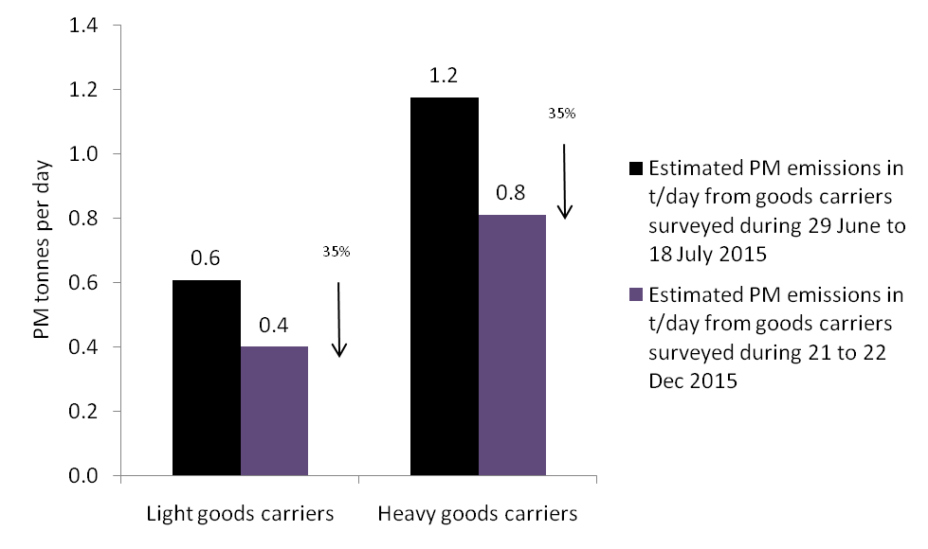
Source: CSE estimates based on vehicle data provided by the CSE hired survey agency V R TECHNICHE Consultants Pvt Ltd, NOIDA, UP
b. NOx emission load from goods carriers
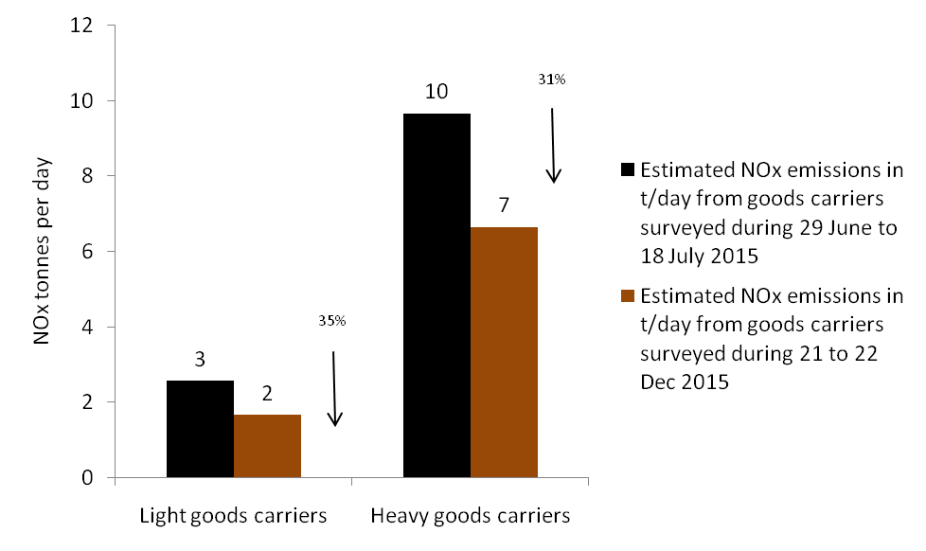
Source: CSE estimates based on vehicle data provided by the CSE hired survey agency V R TECHNICHE Consultants Pvt Ltd, NOIDA, UP

3. Trucks are mainly responsible for pollution during night, as was visible in the previous years. To understand the impact of the reduction in the numbers of vehicles on air quality, EPCA compared the night pollution levels of the previous year. It has found a clear trend showing that the concentration of PM 2.5 is lower this winter in the night, as compared to the previous year.
Graph2: Average night peak pollution has drops this winter in comparison to last winter
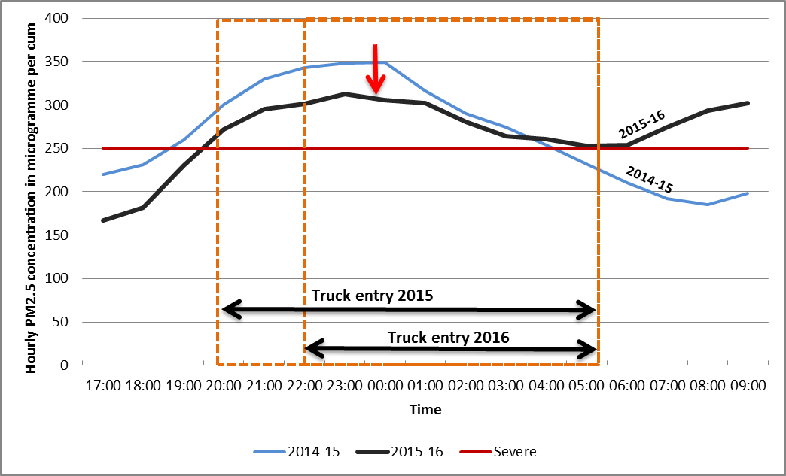
Source: Based on DPCC Real Time Monitoring Data
- EPCA has also compared the pollution trends for this winter of 2015-16 to the previous year. It is clear that weather plays a critical role in pollution episodes. In winter, as compared to summer, there is more inversion – which settles the cold closer to land and traps pollution; there is also less wind and more moisture that increases smog. However, each winter the pollution level also varies as this is determined by the amount of wind and rain, which disperses the pollutants.
- This winter of 2015-16 has been the worst, when it comes to pollution as there has been no wind to disperse pollutants and this has been combined with conditions when there is no rain but high moisture.
- The analysis of DPCC data (average of 4 stations across the city), shows that there is a clear trend that is visible since the imposition of ECC and all other steps that are being taken to combat air pollution. Against the previous year, when there is no trend in the reduction of pollution, other than what is caused by weather events, in the current year in spite of adverse weather, the pollution peaks shows a steadily declining trend. This suggests that actions being taken by the Hon’ble Supreme Court are making a difference. It also suggests that levels of pollution are still high and require more enforcement and more steps to combat this deadly health scourge.
Graph 3: Sustained pollution control measures in winter of 2015-16 helped lower the pollution in a systematic fashion
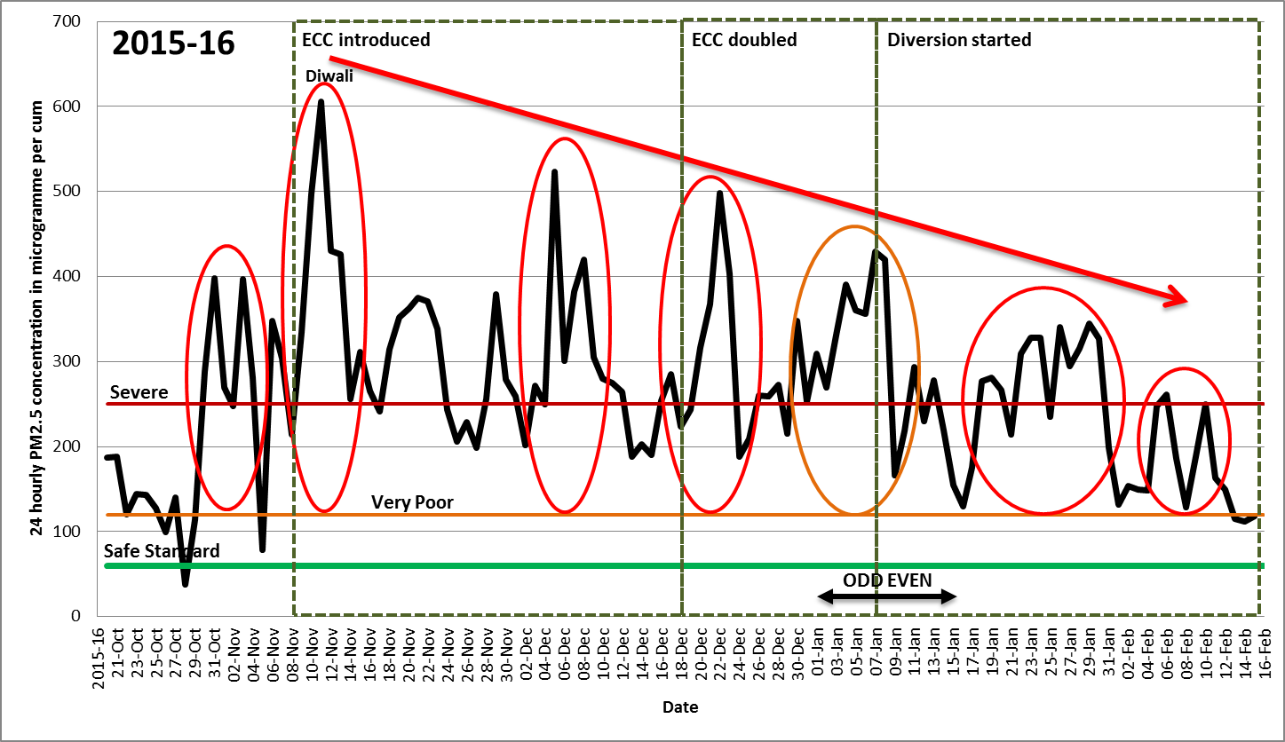
Graph 3: Sustained pollution control measures in winter of 2015-16 helped lower the pollution in a systematic fashion

